COURSE NUMBER: NUR 227

SECTION NUMBER: 001
COURSE TITLE: Health Assessment across the Lifespan ACADEMIC CREDIT: 3 Credit Hours CO/PREREQUISITES: Current enrollment SEMESTER/YEAR: Fall 2026
FACULTY: Sandra Neilsen, PhD, MSN, BSN, RN, CNE
Assistant Professor
mailto:sdknigh@isltu.edu
Edwards Hall Office 219
Illinois State University Normal, IL 61790-5180

OFFICE HOURS: 9:00 am – 11 am, Monday -Friday, and throughout the week by email appointment
By appointment only (Zoom or in person)

CATALOG DESCRIPTION:
Expansion of basic knowledge and skills of physical assessment with added dimensions of psychosocial, cultural, and spiritual needs of clients across the life span.

COURSE OVERVIEW:
The focus of this online course is health assessment across the lifespan. The course expands on basic physical assessment knowledge and skills and adds dimensions of clients of all ages’ psychosocial, cultural, and spiritual needs. Emphasis is placed on nurse-client interactions that facilitate a comprehensive assessment of the whole person. Data from this assessment are used to formulate nursing diagnoses that lead to teaching-learning interventions aimed at health promotion and client self-assessment.

COURSE OUTCOMES:
At the successful completion of this course, students will be able to:
- Collect accurate health information data in an organized and efficient manner that appropriately delineates the individual’s health status and social determinants of health. (Addresses Program Outcome 1)
- Interpret health assessment data, including normal and abnormal data, anticipating appropriate evidence-based nursing interventions. (Addresses Program Outcome 2)
- Communicate health assessment data to appropriate interprofessional care team members utilizing electronic, verbal, and written communication modalities in a systematic, professional, and efficient manner. (Addresses Program Outcome 2)
- Prioritize evidence-based, equitable, and patient-centered care interventions using clinical judgment to advocate for evidence-based and equitable care. (Addresses Program Outcome 6)

- Manage health assessment data utilizing electronic documentation and team-based communication systems. (Addresses Program Outcome 3)
- Identify health promotion interventions, including patient and family education. (Addresses Program Outcome 3)

REQUIRED RESOURCES:
American Psychological Association (2020). Publication Manual of the American Psychological Association: The Official Guide to APA Style (7th ed.). American Psychological Association.
Jarvis, C. (2023). Physical examination and health assessment (9th ed.). Elsevier.
Shadow Health. (2017). Digital Clinical Experience (Version 5.0 [Software] (ISBN: 978-0-9897888-1-6).
ALTERNATE for Jarvis
:An alternate text may be used instead of Jarvis we suggest:
Nursing Skills Open Resources for Nursing (Open RN); Ernstmeyer K, Christman E, editors. Nursing Skills [Internet]. Eau Claire (WI): Chippewa Valley Technical College; 2021. Chapter 1 General Survey. Available from: https://www.ncbi.nlm.nih.gov/books/NBK593193/

MATERIALS Estimated Cost
APA: $32 used is okay, online information is generally accurate to cite and reference all materials
Jarvis: $61-130 used is okay.
Shadow Health Virtual Simulation Learning: $120 must purchase

REQUIRED ASSIGNMENTS:
Signed Syllabus
Digital Experience Orientation Communication and Documentation Tutorials Shadow Health Assessments on Tina
Respiratory HEENT
Skin, Hair, & Nails Cardiovascular Musculoskeletal Abdominal Neurological Discharge

REQUIRED QUIZZES:
Respiratory HEENT
Integumentary Cardiovascular Musculoskeletal Abdominal Neurological

REQUIRED EXAMS:
Cough on Danny Chest pain on Brian
Abdominal Pain on Esther
Comprehensive Assessment on Tina (Final Exam)

STUDENT RESPONSIBILITIES

Learning is an active process that results from exposure to information, ideas, and experiences followed by reflection, as such, students will be Responsible for:
- Behavior consistent with being in a professional environment, the Illinois State University Code of Student Conduct, and the Health Insurance Portability and Accountability Act of 1996 (HIPAA)
- Students may not photograph or use audio or video devices to record classroom lectures or discussions or visual materials that accompany them (e.g., lecture slides, whiteboard notes/equations, quizzes, assignments, or care plans), without express written permission from the course faculty.
- Students may not share any course materials, including but not limited to lecture slides, whiteboard notes/equations, quizzes, assignments, or care plans with people who are not currently enrolled in this course without express written permission from the course faculty.
- Students spend 2-3 hours outside class to read, study, and review content per hour of class.
- Students are expected to attend class and clinical per MCN Student Handbook. If students are going to be absent, they should indicate their absence by an email notification prior to the class/clinical time.
- Students must contact the instructor at least 48 hours before the exam time if they are unable to take the exam at the scheduled time. If students are unprepared to take the exam (ex., forgetting to bring a laptop; laptop not ready with exam format), they are considered to have missed the exam, resulting in a 5% decrease in total score according to the MCN Student Handbook.

STUDENT PERFORMANCE EVALUATION METHODS:
To ensure test-taking security and consistent testing practices, the Mennonite College of Nursing (MCN) uses the National Council of State Boards of Nursing (NCSBN) rules for taking the National Council Licensure Exam (NCLEX). The testing guidelines are published in the MCN Student Handbook.

The Mennonite College of Nursing grading scale is:
A = 90-100% / B = 82-89% / C = 74-81% / D= 66-73% / F = less than 66%

*It is the student’s responsibility to monitor course points throughout the semester and notify the instructor promptly (within two weeks of due date) if an issue with grade submission is noted (eg, missing or incorrect points on assignments).

Grading Philosophy: Instructors record the number of points a student earns. Instructors do not “award” points or give extra points. Students are not in competition for points; it is possible for all or no students to achieve an A, a B, a C, or even a D or F score.

Combined unit and final exam scores must be 74% or higher for students to receive a passing grade in the course. If the student does not accrue 74% on the combined unit and final exam, the student will fail the course with a “D” or “F,” depending on the number of points accrued. The student will fail the course and the exam average will be the final grade. No exams will be rounded. This course is graded using points/weighted categories according to the following:
Letter Grade | Minimum Points required
A | 360
B | 328
C | 296
D | 264
F | 0

Gradebook Items | Points
Signed Syllabus Page | 10
Digital Experience Orientation | 5
Communication and Documentation Tutorials | 5
Assessments on Tina (8 x 10 pts. ea.) | 80
Single-System Quizzes (7 x 20 pts ea.) | 140
Focused Exam (3 x 40 pts ea.) | 120
Comprehensive Assessment (Final Exam) | 40
TOTAL | 400

INSTRUCTIONAL METHODS
Self-directed completion of assigned readings Shadow Health Virtual Simulation Learning
- Virtual Demonstration and documentation of single-system assessment
- Virtual Demonstration and documentation of Focused Assessment Exams
- Virtual Demonstration of a comprehensive assessment

SHADOW HEALTH PURCHASING
For access to your Shadow Health Digital Clinical Experiences, please visit the following: https://evolve.elsevier.com/cs/product/9780323753678?role=student and purchase by clicking “Register”.
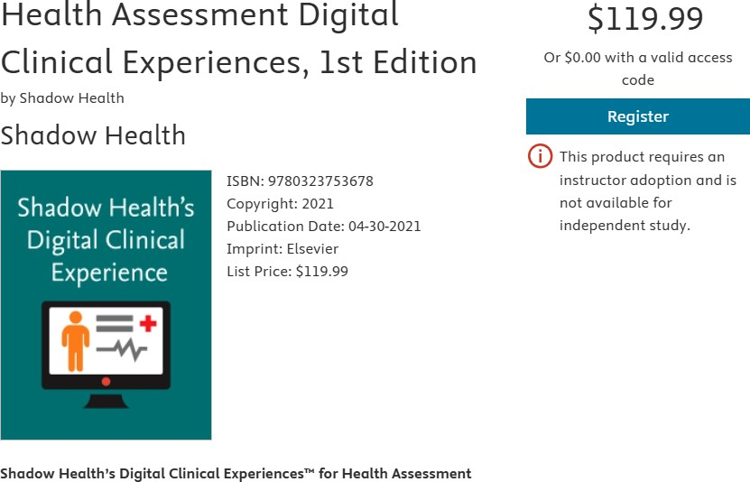
Once purchased, you will need to enroll in the specific course. Please follow the instructions below for Shadow Health course registration and the necessary code, which you should get once you pay for the Shadow Health Course.
Note the course ID is 165730_ilstu_5002
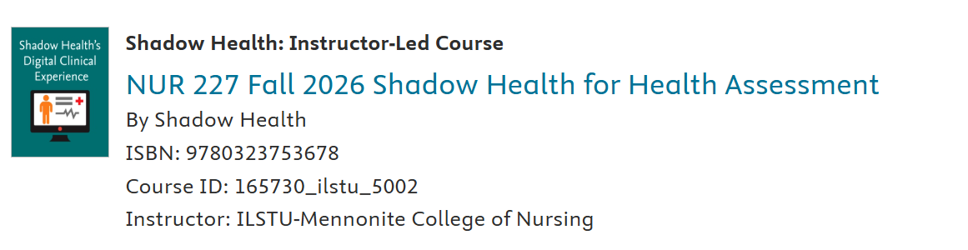
Using Shadow Health
Please note that Google Chrome is the recommended browser for Shadow Health course access. For a brief overview of the Shadow Health component, please review the linked video.

Evolve Technical Support Link:
800.222.9570 (Monday-Friday 6 am to 12 am Central Standard time (CST) ; Saturday-Sunday 9 am-9 pm CST). Contact Shadow Health with any questions or technical issues regarding Shadow Health before contacting your instructor.

Shadow Health grading method: Digital Clinical Experience (DCE)
All Shadow Health assignments will be graded using the DCE Score. Reopenings and multiple attempts are allowed for specific assignments and will be noted in the Shadow Health assignment instructions.
The Shadow Health™ Digital Clinical Experience™ (DCE) provides a dynamic, immersive experience designed to improve your skills and clinical reasoning through interactions with digital standardized patients. Although these patients are digital, each breathes, speaks, and has a complex medical and psychosocial history. The DCE is free of many constraints and interruptions found in hospital or clinical settings. This unique simulation experience allows you to conduct in-depth patient exams and interviews at your own pace. Because the exams are in-depth, these assignments often take over an hour to complete. Please plan enough time to complete your weekly assignments. We will be completing Shadow Health assignments throughout the course. You can make corrections or additions to all assignments to implement the immediate feedback that Shadow Health provides you with on each assignment. Our goal is to set you up for success and improve your critical thinking and patient assessment skills.

LATE WORK POLICY
Late work may only be considered if the instructor is contacted BEFORE the assignment is due.

Academic integrity
As per the MCN Student Handbook, students must follow all policies relating to class.

As per the Illinois State University Code of Student Conduct: Academic Integrity Policy the faculty retains the right to determine a grade penalty for unauthorized means of assistance (books, notes, papers, articles, third parties, generative artificial intelligence) to complete written assignments.
- Possessing or utilizing any means of unauthorized assistance to complete an examination and communicating any content about examinations before, during, or after completion, and being involved in the unauthorized collection, distribution, solicitation, or sale of academic materials completed by a third party is a violation of the Student Code of Conduct.
- Code of Conduct Violations will impact grades, which could lead to academic action up to and including termination from the program, and alleged violations of the Student Code of Conduct, which could lead to disciplinary action up to and including dismissal.
- Content generated by an Artificial Intelligence third-party service or site (AI-generated content) without proper authorization and attribution is a form of academic dishonesty. If you are unsure about whether something used in your work requires attribution, please reach out to me to discuss it as soon as possible. Allegations of academic dishonesty will be referred to Student Conduct and Community Responsibilities for review under the Student Code of Conduct. Students found responsible for academic dishonesty may also be assigned a grade penalty by the instructor.
- Any faculty or Shadow Health-developed course materials may not be entered into an AI service for any reason.

STUDENT ACCESS AND ACCOMMODATIONS:
Any student needing to arrange a reasonable accommodation for a documented disability and/or medical/mental health condition should contact Student Access and Accommodation Services at 308 Fell Hall, Office Phone (309) 438-5853, Video Phone (309) 319-7682 or visit the website at StudentAccess.IllinoisState.edu.

MENNONITE COLLEGE OF NURSING HANDBOOK:
Students are responsible for reviewing and adhering to all policies and procedures outlined in the Mennonite College of Nursing Student Handbook.

ILLINOIS STATE UNIVERSITY STUDENT CODE OF CONDUCT:
Students are responsible for reviewing and adhering to all policies and procedures outlined in the Illinois State University Code of Student Conduct.

HEALTH INSURANCE PORTABILITY AND ACCOUNTABILITY ACT OF 1996 (HIPAA) COMPLIANCE
Maintain confidentiality of all client information. To avoid academic and legal penalty under the HIPAA law, DO NOT discuss your client outside of clinical, use his or her full names, initials, or other identifiers on your paperwork, take home documents with identifiable information, leave charting/paperwork unattended in the clinical site, or post information or photos of clients on your social media accounts. Be vigilant in your discretion and protection of clients’ privacy. HIPAA Home | HHS.gov

The course instructor retains the right to make exceptions and adjustments to these guidelines as needed. Any changes or adjustments are effective upon notification of the changes in Canvas.

TOPICAL OUTLINE / TENTATIVE SCHEDULE:
WEEK/DATE | TOPICAL OUTLINE
WEEK 1  Mon, Aug 18 – Sun, Aug 24 | Introduction and Orientation Evidence-Based Assessment Interview & Cultural Competence
WEEK 2  Mon, Aug 25 – Sun, Aug 31 | Assessment Techniques:  Respiratory System Assessment, Clinical Data Interpretation & Clinical Judgement
WEEK 3  (Labor Day: Mon)  Tues, Sept 2 – Sun, Sept 7 | Assessment Techniques: HEENT, Integumentary, Skin, Hair, & Nail System Assessment, Clinical Data Interpretation & Clinical Judgement
WEEK 4  Mon, Sept 8 – Sun, Sept 14 | Assessment Techniques: Cardiovascular System Assessment, Clinical Data Interpretation & Clinical Judgement
WEEK 5  Mon, Sept 15 – Sun, Sept 21 | Assessment Techniques: Musculoskeletal System Assessment, Clinical Data Interpretation & Clinical Judgement
WEEK 6  Mon, Sept 22 – Sun, Sept 28 | Assessment Techniques: Abdomen Assessment, Clinical Data Interpretation & Clinical Judgement
WEEK 7  Mon, Sept 29 – Sun, Oct 5 | Assessment Techniques: Neurological System Assessment, Clinical Data Interpretation & Clinical Judgement
WEEK 8  Mon, Oct 6 – Sun, Oct 12 | Assessment Techniques: Comprehensive Health Assessment across the lifespan.

NUR 227

Signature Page for Course Syllabus and Academic Integrity Statement
Directions: Please sign this page and upload it as a PDF file as a Canvas assignment submission.

My signature below indicates that I have read, understood, and clarified information in the course syllabus, including the academic integrity statement. (To receive credit, it must be signed with a signature and submitted as a PDF file (not a photo).

Printed Name:

Signature: Date:

