Welcome to CROSS CULTURAL BEHAVIOR IN BUSINESS Spring 2026
Department of Management, College of Business, Illinois State University

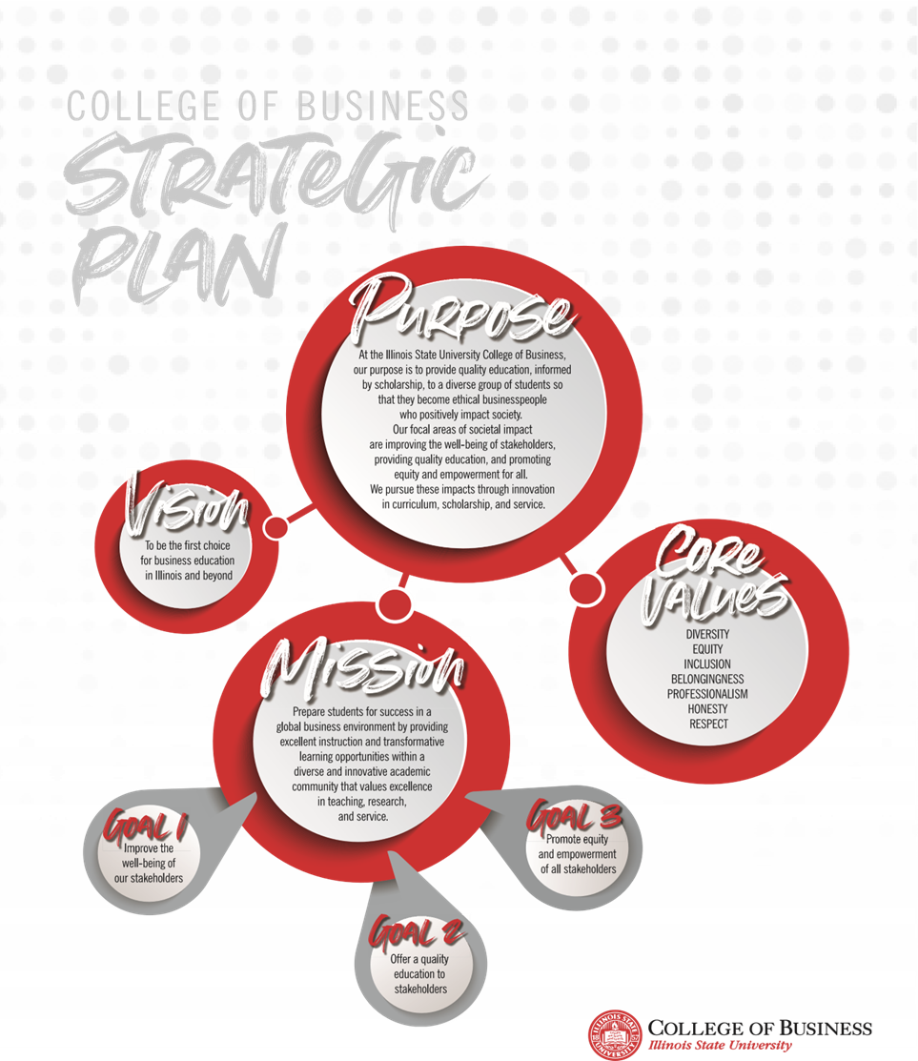

COURSE INFORMATION
Professor: Dr. Barbara Ribbens
Course No: MGT 349 Section 091
Course Title: Cross Cultural Behavior in Business
Prerequisites: MGT 220 or 221
Credit Hours: 3.0
Time and Location: Face to Face Jan 5-9, then virtually though May 2

INSTRUCTOR INFORMATION
Phone: 309-438-3210
E-mail: bribben@ilstu.edu
Office Location: SFHB 315
Office Hours: M & W 11-12 and T and Th 2-3 and available by appointment

RESOURCES / MATERIALS
Required Materials:
- Cultures and Organizations: Software of the Mind, by Hofstede, Hofstede and Minkov, 3rd edition, 2010, ISBN 978-0-07-166418-9 aka Hofstede on schedule – AVAILABLE through Milner as free link at:
https://i-share-isu.primo.exlibrisgroup.com/permalink/01CARLI_ISU/179j7oq/alma9921414966905845
- Packback – to be explained the first day of class
- Other Internet resources and readings as assigned

COURSE DESCRIPTION

We will study the unique issues of organizational behavior in non-native cultures. We will discuss management situations where members of more than one cultural group are included, along with strategies for maximum effectiveness in such situations. Culture is fundamental to human interaction, especially in multicultural and cross border situations, thus it is covered to some degree in every international course, but this course will focus on culture as the key area and provide the deepest coverage. Expect some overlaps of topic and content with INB 225, MQM 350, and MKT 350 and potentially other courses as well to a lesser degree. This course begins with an analysis of your culture to develop self awareness of bias and identity and then develops cultural abilities to interact with people of different cultural backgrounds. There is a strong theme throughout this class of diversity, equity and inclusion across all types of differences.

LEARNING GOALS

By the end of this course, students will…
1. be able to apply cross-cultural theory to the practice of management in attitude and behavior by identifying difference and the richness diversity brings to organizations (IDEAS LO 2)
2. increase awareness of their own cultural programming and become more adept at empathizing with and managing people from cultures other than their own (IDEAS LO 3, 5)
3. develop cosmopolitan skills of analysis to understand historical roots of culture and how that shapes workplace attitudes and interactions (IDEAS LO 4, 6)
4. expand and refine their intercultural communication and interpersonal skills (with special emphasis on workplace interactions) to be more confident to travel and work in diverse settings
5. engage in critical thinking and expressing your views (verbal and written) with clarity about cultural differences (IDEAS LO 2, 4, 6)
6. evaluate current situations to anticipate opportunities and challenges in business settings based on cultures represented (IDEAS LO 1)

COURSE REQUIREMENTS

Exams: Two exams will test your understanding of culture. The exams will consist of a combination of multiple choice, short answer questions and long answer questions. The midterm will focus on your understanding of the theory covered in the first half of the class. The final exam will focus on your ability to recognize and apply cultural knowledge to work and life situations, including current events. No make-ups will be given for missing an exam except for university approved absences or verified medical or family emergencies. Please note that job interview, employment, company training / travels etc. do not count as legitimate reasons. Students who have an approved excuse must contact me at least 48 hours before the exam so that the make-up exam can be scheduled. Exams must be done individually.

Assignments: There will be 2 individual assignments and 2 duo assignments; each will be 10% of your final grade. Each will be uniquely suited to increasing your cultural awareness. Duos will be assigned at the beginning of the semester and will be one US student and one international student. These duos will work together across the entire semester providing deep cultural experience. The specific assignment details will be posted in the Assignment section of Canvas including due dates. Students are responsible to manage their time to meet assignment deadlines.

- International Interview – Written Paper Individual
- Culture in Today’s World (CTW on schedule) – Power Point Only Individual
- Cultural Cues – Written Paper Duo
- TED talk summaries (TED on schedule) – Power Point Only Duo

Group Project: Culture is a sociological phenomenon and each of us has unique experiences and perspectives. Midway through the semester, each individual will be assigned to a group to explore workplace culture. The groups will include MGT 349 students based in Illinois and based in Panama. Your team will need to work together virtually to bring your cultural knowledge to bear in making recommendations about the assigned situation.
As part of the group project, you and your group members will make a video PowerPoint presentation sharing your project. The presentation should include key elements about involved aspects of culture and your group’s recommendations. The presentation will be evaluated upon the content, organization, and delivery of the presentation.

Participation: Both attendance and verbal interaction in class are critical to the learning process in this class. Absences will have a significant negative impact on your grade since so much of the processing of the material will happen in course sessions. Unexcused absences beyond 2 during the face to face week will lead to reducing the final grade by one letter grade. Since an important aspect of this course is interactive learning, your contribution to class discussions is vital to your knowledge development. Each of you brings an important perspective that can spur the thinking and development of your peers! Thus 10% of your grade will be based on your involvement in the discussions and exercises (both attendance and engagement count) during the face to face week.

Outside of class sessions, you will use Packback as a mechanism for continuing discussion about culture for 10% of your final grade. Except for the first week of class and Break weeks, you will be expected to post about 1 question and 2-3 answers each week. To keep a B grade on this segment of participation, 10 posts and 30 replies are required with at least 50% of your replies being to an original post by someone from the other site (B minimum receives 8/10). An A grade is earned by going above and beyond in terms of quantity and/or quality in your posts. Packback participation will account for 10% of your total course grade.

E-Mail etiquette: Please send your e-mail using your university account. In the subject line, mention MQM 349 and then a very brief topic (e.g., ‘Feb 9 absence’). Address me as Dr. or Professor Ribbens. Type your full name at the bottom. E-mails that don’t have these attributes will be ignored.

GRADE DISTRIBUTION
 | Item | Percent of course grade
 | Exam 1 | 10
 | Exam 2 | 10
 | Assignments | 40
 | Group Project | 20
 | Participation | 20
 |  | 100%

ADDITIONAL INFORMATION
Academic Integrity
Students enrolled in College of Business classes are expected to maintain high standards of ethical conduct within the classroom and when completing assignments, projects, and/or exams. Plagiarism and other forms of academic dishonesty such as cheating will not be tolerated. Students are expected to provide appropriate citations for non-original writing even if the original work is paraphrased. Penalties for plagiarism and other forms of academic dishonesty may be severe.
All students in this course are expected to be familiar with the College of Business Standards of Professional Behavior and Ethical Standards found on https://business.illinoisstate.edu/about/facts/ . Please note that only bottled water may be consumed in the classroom wing of the State Farm Hall of Business and that all cell phones and other electronic devices should be turned off and stored away during classes, unless permission is otherwise granted by the instructor.
I expect you to conduct yourself (i.e., think, talk and behave) in a professional manner inside the classroom (physical or virtual!). This means that you will (1) be prepared for each class meeting in a manner that shows that you are eager and ready to learn and build on your existing knowledge, (2) participate actively in class discussions, (3) read and analyze the required material for the day, (4) acquire additional information, as necessary, from sources outside the course readings, (6) respect others’ points of view in the classroom, as well as respect each person in the classroom, and (7) produce your own assignments / work.
Students must obtain written permission from the instructor if they wish to reproduce in any manner instructional material used in the course. This includes photographing classroom lectures or discussions or recording them using audio or video devices. This restriction also includes visual materials that accompany the lecture/discussion, such as lecture slides, whiteboard notes/equations, etc. Such recordings are to be used solely for the purposes of individual or group study with other students enrolled in the class in that semester. They may not be reproduced, shared in any way (including electronically or posting in any web environment) with those not in the class in that semester. Students with disabilities who need to record classroom lectures or discussions must contact Student Access and Accommodation Services to register, request and be approved for an accommodation.
Students who violate this policy will be reported to SCCR and may be subject to both legal sanctions for violations of copyright law and disciplinary action under the University’s Code of Student Conduct. Posting any class material to websites such as Course Hero is in violation of this policy.
A Note about Mental Health!!
Life at college can get very complicated. Students sometimes feel overwhelmed, lost, experience anxiety or depression, struggle with relationship difficulties or diminished self-esteem. However, many of these issues can be effectively addressed with a little help. Student Counseling Services (SCS) helps students cope with difficult emotions and life stressors. Student Counseling Services is staffed by experienced, professional psychologists and counselors, who are attuned to the needs of college students. The services are FREE and completely confidential. Find out more at Counseling.IllinoisState.edu or by calling (309) 438-3655.
Accommodations For Students
Any student needing to arrange a reasonable accommodation for a documented disability and/or medical/mental health condition should contact Student Access and Accommodation Services at 350 Fell Hall, (309) 438-5853, or visit the website at StudentAccess.IllinoisState.edu.

COURSE CALENDAR – This calendar focuses on reading deadlines, major assignments and exams. Class meeting formats will be provided in Canvas with more details.
WEEK | MO. | DATE | TOPIC | ASSIGNMENT DUE
1 | Jan | T 13 | Orientation and Course Overview | Read Hofstede Ch. 1
 |  | Th 15 | What is Culture? | Read 2 assigned articles in Files in Canvas
2 |  | T 20 | Comparing Culture Studies Trompenaars and GLOBE | Read Hofstede Ch 2
 |  | Th 22 | How do we examine cultural difference?
3 |  | T 27 | Dim 1: Power Distance | Read Hofstede Ch. 3
 |  | Th 29 | Dim 2: Individualism vs. Collectivism | Read Hofstede Ch. 4
4 | Feb | 3 | Dim 3: Masculinity v. Femininity | Read Hofstede Ch. 5
 |  | 5 | Dim 4: Uncertainty Avoidance | Read Hofstede Ch. 6 International Interview Due Feb 2
5 |  | 10 | Dim 5: Time Orientation/ | Read Hofstede Ch. 7
6 |  | 12 | Dim 6: Indulgence v Restraint, Subjective Well-being | Read Hofstede Ch. 8
7 |  | 16-20 | CTW Presentations | CTW Due
8 |  | 23-27 | CTW Presentations and Exam Review
9 | March | 2-6 | Exam 1
10 |  | 9-13 | Illinois Spring Break
11 |  | 16-20 | Decision making, Leadership and Communication | Read Hofstede Ch. 9 and 11
12 |  | 23-27 | Motivation and group behavior | Ted Talks Due
13 | April | March 30-Apr 3 | HR, Expatriate | Read Hofstede Ch. 10
14 |  | 6-10 | Org. Culture / Holy Week
15 |  | 13-17 | Cultural Evolution and Change | Read Hofstede Ch. 12, Cultural Cues Paper due
16 |  | 20-24 | Group Project Discussions and Semester Review | Group Presentation Due
17 |  | Apr 27-May 1 | Online/Take Home Exam | Watch Canvas for timing details!

