Welcome to INB 225 – Understanding The Global Business Environment!

COLLEGE OF BUSINESS
ILLINOIS STATE UNIVERSITY

Spring 2026

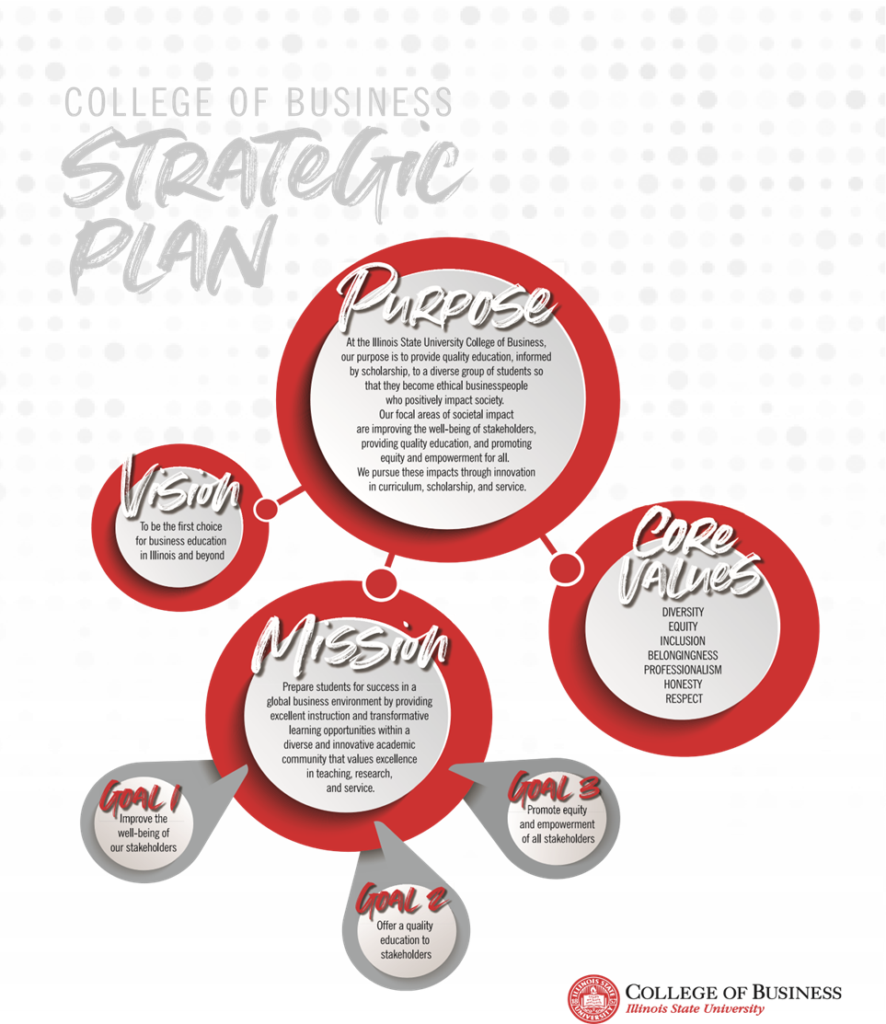
COURSE INFORMATION

Instructor: Dr. Barbara Ribbens
Course Number & Title: INB 225 Understanding the Global Business Environment
Prerequisites: ECO 101/102 or 105
Credit Hours: 3
Time and Location: T and Th 3:30 -4:50 pm SFHB 354, see schedule for hybrid details

INSTRUCTOR INFORMATION
Phone/email: 438-3283 or bribben@ilstu.edu
Office Location: SFHB 315
Office Hours: M, T and W 2-3 pm, T and Th 1-2 a.m. and by appointment

RESOURCES/MATERIALS

International Business, 2025 Edition (ebook with Connect)
By Michael Geringer and Jeanne McNett, McGraw-Hill © 2025
ILabz, Details for purchase will be in Canvas with the first assignment using it
Various Articles and events as assigned

COURSE COMPETENCIES

This course is designed to help you learn how to work in the complex global business environment. By design this course interweaves theory and concept with awareness and analysis of current events and real situations. It will help you understand and navigate:
- The complex global business environment including opportunities and challenges
- Political, economic, legal and cultural differences affecting global business
- The historic and current role of global trade and foreign direct investment
- The global monetary system and its effects on business enterprises
- How an international setting affects business decisions
- The communication skills and professional demands of a career in global business

GRADING STRUCTURE

Midterm Exam 10%
Final Exam 15%
International Business Update 5%
ILabz 15%
Group Project 15%
Connect Assignments 25%
International event reflection 5%
In Class Participation 10%

100%

COURSE REQUIREMENTS

Exams

One midterm exam and one final exam will be given. Each will focus on a set of chapters, but the final exam will also include a section integrating the overall concepts of the entire semester. Content may be covered in class that is not in the text; powerpoints will be uploaded into Canvas for your review. Generally non-text info will be covered only by short answer questions. The exams may include a variety of question types including multiple choice, matching, short answer, and for the final, a long essay synthesizing the course in a structured response to a current event. This long essay will be 5% of the final grade. This essay will be applied and cumulative. No makeup exams will be given unless there is a university approved absence or a verified emergency.

International Business Update

Every student will do one International Business Updates. Early in the semester I will supply a sign up sheet with dates. This is a short presentation (4-6 minutes) on a current international business event. You can find events in various business websites/publications such as Wall St. Journal, Forbes, Financial Times, Economist, Fortune, etc. but your analysis must be based on a complete published article in a legitimate business publication. As we go through the semester, some topics may come up several times but each time a new approach or direction should be taken or an update of new material provided. For example, one semester we had 4 people present on the Greek banking crisis, but each presentation took a unique viewpoint or added new information as the events unfolded.
Read the article thoroughly and prepare a presentation of 4 to 6 content power point slides that contain: 1) a very short summary of the event, 2) Why is this event interesting/important? 3) How does this event relate to our course? 4) What can we learn from this event? 5) What should business execs know about this event? These headings do NOT need to be the titles of your slides, but these are the content I will be using to evaluate how well you teach the class about this event. Note that the title slide and reference list slide do NOT count as content slides. You will orally present to the class for 4-6 minutes.

iLabz Homework

To increase your experience with the material, you will do 3 iLabz assignments which will give you more experience with the content in a different setting. Each will be clearly assigned with a due date and specific instructions and each will be 5% of your semester grade. Details will be posted in Canvas but the final iLabz will provide tools and experience to use in your final group project.

Group Project

You will do one group project to assess the viability of a specific company in a particular industry entering three (or 4 if you have 4 group members) countries. This will be a major project which involves examining all the course material throughout the semester. The output will consist of a class presentation and power point submission. Details will be in Canvas.
This is 15% of your grade and requires professional communication, team coordination, and comprehensive multidimensional analysis. A chart comparing the three countries MUST be included in your analysis. Good presentations will be 10-12 slides but they are judged based on quality, not quantity. You will have 10-11 minutes to present your slides to the class. Do NOT procrastinate on this project since it will have a big effect on your final grade. Always remember to accurately document sources with a complete citation including date since this is crucial in assessing the credibility and accuracy of information.

Connect Homework

This tool will provide you the chance to review the book content and process the terms and concepts. This site hosts the ebook and due dates will be shown on the Connect calendar. Those dates are hard dates and the assignments will close at that time.

Reflections on international event

There will be a variety of international events and speakers this semester on campus. You will attend 1 of these and write a 1 page reflection of the event attaching any proof of attendance (e.g. program, extra credit slip, photo, etc.) I will make you aware of a variety of these events, but if you find others that are particularly interesting to you, please feel free to ask if they will count. See this as an opportunity to try something new and stretch yourself! Part of being aware of global business is getting outside your comfort zone to try new things.

In Class Attendance and Participation

Participation scores will be calculated based on attendance and my notes on your class discussion involvement (both quality and quantity). We will be hybrid so class only meets once most weeks except the first and last weeks of the semester. Students are expected to be in class prepared to discuss both the presented and the assigned content for that day. Questions to presenters of IBU presentations count toward class participation. I may call on anyone in the room to give their opinion or explain basic concepts from the content assigned for that day. You will be expected to sign in at each class to facilitate attendance recordkeeping; being more than 5 minutes late counts as an absence unless it is preapproved. You can’t earn participation points if you are not in class. Your final grade will start dropping from the calculated grade by 1 letter grade with each additional absence beyond 2 unexcused absences.

Course Communication

We will use Canvas as our main communication tool; you should check Canvas at least 48 hours before every class. As current events unfold, I may post articles to read for class in Announcements. Note that I expect you to read all assigned material; I will only highlight a few key ideas, but Connect and multiple choice exams will cover the entire text material assigned. Thus, if you don’t understand something or want to discuss a particular topic for more clarity, please ask in class or come to see me so I can help you.

ADDITIONAL INFORMATION
Please note that only bottled water may be consumed in the classroom wing of the College of Business Building. Smartphones and other electronic devices should be turned off and stored away during classes. Laptops can be used for note taking during lectures and group discussions, but MUST be put away when other students are presenting to focus fully on learning from each other’s research. Anyone found using a laptop for outside of class purposes during class will be prohibited from using their laptop during class for the remainder of the semester and can result in a lowering of your participation grade.

Academic Integrity

Students enrolled in College of Business classes are expected to maintain high standards of ethical conduct within the classroom and when completing assignments, projects, and/or exams. Plagiarism and other forms of academic dishonesty such as cheating will not be tolerated. Students are expected to provide appropriate citations for non-original writing even if the original work is paraphrased. Penalties for plagiarism and other forms of academic dishonesty may be severe.
All students in this course are expected to be familiar with the College of Business Standards of Professional Behavior and Ethical Standards found on https://business.illinoisstate.edu/about/facts/ . Please note that only bottled water may be consumed in the classroom wing of the State Farm Hall of Business and that all cell phones and other electronic devices should be turned off and stored away during classes, unless permission is otherwise granted by the instructor.

A Note about Mental Health!!

Life at college can get very complicated. Students sometimes feel overwhelmed, lost, experience anxiety or depression, struggle with relationship difficulties or diminished self-esteem. However, many of these issues can be effectively addressed with a little help. Student Counseling Services (SCS) helps students cope with difficult emotions and life stressors. Student Counseling Services is staffed by experienced, professional psychologists and counselors, who are attuned to the needs of college students. The services are FREE and completely confidential. Find out more at Counseling.IllinoisState.edu or by calling (309) 438-3655.

Accommodations For Students

Any student needing to arrange a reasonable accommodation for a documented disability and/or medical/mental health condition should contact Student Access and Accommodation Services at 350 Fell Hall, (309) 438-5853, or visit the website at StudentAccess.IllinoisState.edu.

Spring 2026 COURSE CALENDAR
WEEK | MO. | DATE | TOPIC | ASSIGNMENT
1 | Jan. | Tue. 13 | Welcome
 |  | Thu. 15 | The Challenging Context of IB | Mod 1
2 |  | Tue. 20 | International Institutions | Mod A
 |  | Thu. 22 | International Trade and Investment | Mod 2
3 |  | Tue. 27
 |  | Thu. 29 | Sociocultural Forces | Mod 3
4 | Feb | Tue. 3
 |  | Thu. 5 | Sustainability and Natural Resources | Mod 4
5 |  | Tue. 10 |  | iLabz Cultural Intelligence Due
 |  | Thu. 12 | Political Forces that Affect Global Trade | Mod 5
6 |  | Tue. 17
 |  | Thu. 19 | International Monetary System and Financial Forces | Mod 8
7 |  | Tue. 24
 |  | Thu. 26 | Intellectual Property Rights and Other Legal Forces | Mod 6
8 | March | Tue. 3
 |  | Thu. 5 | Economic and Socioeconomic Forces | Mod 7 – iLabz Foreign Exchange Due
 |  |  | Spring Break
9 |  | Tue. 17
 |  | Thu. 19 | Midterm Exam
10 |  | Tue. 24 | Global Market Assessment and Entry | Mod 12
 |  | Thu. 26
11 |  | Tue. 31 | International Competitive Strategy | Mod 9
 | April | Thu. 2 |  | iLabz Market Entry Due
12 |  | Tue.7 | Org. Design and Control | Mod 10
 |  | Thu. 9
13 |  | Tue. 14 | Export and Import Practices | Mod B
 |  | Thu 16 | Global Operations and Supply Chain | Mod C
14 |  | Tue. 21
 |  | Thu. 23 | Global Leadership Issues and Practices | Mod 11
15 |  | Tue. 28 | Project Presentations
 |  | Thu. 30 | Project Presentations | Upload presentation into Canvas

Highlighted boxes are hybrid days – We will not meet in person but you will have outside of class online work to complete for those days.

Final Exam will be done virtually with both a multiple choice and a writing section during Exam Week with due dates at the time scheduled by the Registrar’s Office.

